CHAPTER I
INTRODUCTION
1.1 Project Context
The use of information technology in education has largely revolutionized the manner in which academic institutions handle documents and assure academic integrity. Computerized repositories and plagiarism detection software have become a must to ensure quality education and intellectual dishonesty.
Even in local colleges, document submission and plagiarism detection remain in part manual in most academic institutions. Students present research papers, and instructors use independent tools or go through a manual check to confirm the originality. This disjointed method can lead to inefficiency, procrastinations and variation in the assessments of academic work.
According to observations and general institutional practices, there are a number of loopholes including the slow checking of plagiarism, absence of centralized repositories, inability to identify partial similarities, and poor access control systems. These problems may undermine academic integrity and deter proper document management.
Driven by these difficulties, this project seeks to build an academic repository (with web-based interface) with inbuilt plagiarism detection through TF-IDF and cosine similarity. The system aims to offer an integrated, effective and safe platform of management of academic documents.

1.2 Purpose and Description
This study aims to design and develop a web-based academic repository with automated plagiarism detection in the quest to enhance the management of documents and originality of academic submissions.
The system has three user types namely: Guest Users, Registered Users, and Administrators. Guest users have access to restricted information, registered users are able to post and analyze documents, administrators are able to manage the system and track reports. JWT-based authentication is used to enforce access control, and secure that only authorized users are allowed to perform a certain action.
1.3 Statement of the Problem
Document management and plagiarism check of academic work is still done conventionally. Documents are not stored in a central place, plagiarism checking is inefficient, and it is hard to find similar documents. These issues impact the integrity and quality of the academic process.
This research seeks to address the questions:
- How to build a system to manage academic documents?
- How can the system identify the similarity of documents?
- How can the system increase speed of plagiarism detection?
- How can the system be a safe and user-friendly system?
1.3.1 General Objective

To develop a web application for storing academic documents with plagiarism check using TF-IDF and cosine similarity.
1.3.2 Specific Objectives
- To develop a repository for academic documents
- To enable file uploads and management
- To create plagiarism check using TF-IDF and cosine similarity
- To show the results of similarities
- To develop a secure and user-friendly system
1.4 Significance of the Study
This research has the advantage of offering an effective means of handling academic work and identifying plagiarism to institutions of learning. Students will have a better access to originality checking, and faculty members will be able to spend less time on manual work and enhance evaluation processes.
Administrators are provided with centralization and monitoring. The technical skills of the student developers in the system design and algorithm implementation are also developed by the project.
The research contributes to Sustainable Development Goals, including Quality Education, Innovation, and Strong Institutions, as it allows fostering fairness and transparency in academic evaluation.

1.5 Scope and Delimitation
The system encompasses uploading of documents, managing metadata, plagiarism, and generating reports. It supports PDF, DOCX, and TXT and is based on TF-IDF and cosine similarity algorithms.
However, the system lacks advanced AI-based deep learning models, full multilingual functionality, and fully plagiarizing the whole internet. External APIs and the available datasets can also be important to the system performance.

CHAPTER II
REVIEW OF RELATED LITERATURE
2.1 Related Literature on Academic Digital Repositories
The role of institutional repositories in education is known to play an important role in preserving and sharing scholarly output in higher education. Lynch (2003) stressed that repositories are not just closed-box storage but organizational pledges of stewardship, access and permanence in scholarly view. This point of view is supported by literature on DSpace whereby Smith et al. (2003) introduced repository architecture as a strategic reaction to the fast rise in volume of born-digital academic material and the requirement of institutional ownership of knowledge resources.
Sustainability, interoperability, and policy governance are also shown as a key determinant of repository success in early implementation studies. Smith et al. (2004) presented the topic of operational realities following initial deployment, and outlined that balancing open access aspirations, quality of preservation and sustainability of software architecture should be considered in repository systems. Practically, it justifies the necessity of modular platforms with the assigned roles, metadata discipline, and workflow auditing.
Repository ecosystems were also developed through interoperability standards. The formal scheme adopted was the Open Archives Initiative Protocol for Metadata Harvesting (OAI-PMH) that provided a formal scheme of exposing and harvesting metadata in repositories (Van de Sompel et al). The model of its data provider and service provider illustrates how distributed discovery can be facilitated by repositories without giving up on local control. In case of academic repository projects, this literature assists in making design choices regarding the consistency of metadata, versioning of records and standards-conscientious system development.
2.2 Related Literature on Plagiarism Detection
Detection of plagiarism studies developed to be more exact matching up till the more effective lexical, structural and semantic. A structural route is document fingerprinting, in which representative text signature denotes are compared to find out a match effectively. One of the most referenced methods is the winnowing (Schleimer, Wilkerson, and Aiken, 2003) method that proposed local fingerprinting methods that could be used to find similarities in large volumes of text.
The other large stream is based on text representation in a vector-space. Salton, Wong and Yang introduced a model of automatic indexing as a vector space, and Sparsck Jones gave a statistical interpretation of term specificity, subsequently used to give inverse document frequency weighting. Their works continue to be the centre of focus in contemporary educational plagiarism software due to their explainable character, computational feasibility and document ranking criteria.
Recent reviews indicate that plagiarism detection is a multi-dimensional problem. Alzahrani, Salim and Abraham studied linguistic patterns, textual characteristics and method families applied in detection pipelines. Eisa, Salim and Alzahrani decided to offer the systematic mapping of the techniques and revealed gaps in the detection of the idea plagiarism, visual artifacts, and heavily transformed content. Kakkonen and Mozgovoy studied systems in applied educational contexts found that plagiarism systems differ greatly based on the type of plagiarism, with none being robustly applied in all strategies to conceal the plagiarism.
There is also the role of community benchmarking in the method validation. A collection of evaluation frameworks of plagiarism detection was suggested by Potthast, Stein, Barron-Cedeño and Rosso (2010) so that the comparability of tools and methodologies could improve. This literature would favor the design principle that system outputs would be quantifiable, reproducible and analyzable on multi levels (document-level and segment-level) instead of using a single similarity measure.
2.3 System Technical Background
The system suggests combining the literature-proven methods with the current web architecture. TF-IDF-inspired term weighting and cosine similarity are used in the detection core to rank documents and localize suspicious overlaps by comparison at a paragraph level. This is consistent with information retrieval fundamentals (Salton et al.; Spärck Jones; Manning, Raghavan, and Schütze), but deals with real world educational application, revealing interpretable scores and match contexts.
The implementation of the system comprises a client-server implementation. It has a browser-based presentation interface, an application based on RESTful services, and a data layer comprised of users, documents, paragraphs, and similarity results stored in a relational database. Role-based access control does operationalize repository governance issues pervasive in repository literature by imposing policy limits between guesting, registered user and administrator activity.
Security and reliability are seen as engineering needs as opposed to optional add-ons. Authentication using tokens, hashed passwords, middleware to protect endpoints, upload restrictions, and limited processing flows make the deployment in academic environments safer. It also has an architecture that allows incremental addition of features, e.g. semantic checks and internet-assisted matching, without substituting the underlying explainable detection pipeline.
2.4 Synthesis and Research
The literature on the topic has validated institution repositories as well as plagiarism detectors as mature fields but viable gaps still exist in small-to-medium sized academic setting. A lot of institutions continue to have challenges with integrating repository governance, user-based access policies and understandable similarity analytics into one platform of operation. Current solutions tend to be disjointed: either they concentrate on storing and retrieving, or the ones that check similarities without necessarily having to manage the repository lifecycle in their entirety.
The research gap that the study aims to fill is that repository management and algorithmic plagiarism detection ought to be integrated into a single policy-aware web application that suits academic processes. The project transforms existing literature into an institutional system being implemented by using role-conscious repository features, metadata acquired, document / paragraph similarity, and report-based access control.

CHAPTER III - METHODS
3.1 Model / SDLC
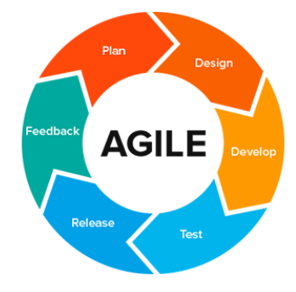
The system used the Agile SDLC model. Agile is used because it is flexible and easy to improve. The system is developed step by step. Each part is built and tested before moving to the next part.
figure 1.

The development steps are:
- Planning
The system and the users of the system. The users include the students, teachers and administrators. Issues with the current system were also identified. A plan was developed to develop the system.
- Data Gathering
The proponents interviewed students and teachers to find out their issues and needs. They also did some observations on how the documents are submitted and verified. This gave them an idea of what to include in the system.
- Design
During this phase, the proponents made the system design. This covers the database, system flow and user interface. Basic diagrams were drawn to illustrate the user interface and user interactions.

- Development
Each module such as logging in, file upload and plagiarism check was developed separately. The parts were then joined to make the system.
- Testing
The proponents tested all the features to ensure that they are functional. Problems were detected and solved. The system was tested repeatedly to ensure that it is safe and easy to use.
- Deployment
The system was tested and then put out for use. It was posted so users can access it via a browser. So, the system can be used by users.
- Maintenance
The system is tracked after it is deployed. Bugs can be resolved, and additional features can be added. The system can be upgraded to enhance efficiency and effectiveness.
3.2 Data Gathering
Data gathering was done in various ways.
- Interview- The proponents interviewed the students and teachers about their report card, checking of plagiarism and how they submit their files.
- Observation- The proponents observed the process. They observed that work is mostly manual and labor-intensive.
- Document Review- The proponents reviewed the documents and systems to know what features are needed.
3.3 Requirements Analysis
The current system's problems were identified after gathering information. There is no centralized system for document management, plagiarism detection is inefficient and content similarity is hard to check. To address these issues, the system has been developed.
The functional requirements describe what the system should do. Users can register and login to the system, upload documents, extract the text, check the similarity, and view the results. But the non-functional requirements describe the system's operation. The system should be user-friendly, secure, quick, and web-based.
3.4 Requirements Documentation
Functional Requirements
ID | Requirement
FR-01 | User can register
FR-02 | User can login
FR-03 | Upload document
FR-04 | Extract text
FR-05 | Check similarity
FR-06 | Show result

Non-Functional Requirements
ID | Requirement
NFR-01 | Fast system
NFR-02 | Secure system
NFR-03 | Easy to use
NFR-04 | Reliable

  - Design of System
3.5.1 Conceptual Framework (IPO Model)
The IPO model demonstrates how the system work converts the user credentials, document files and the user actions into value outputs. The system can also produce the similarity scores, match content, and organize role-based results by employing such processes as text extraction and TF-IDF cosine analysis of similarity.
- User login
- Uploaded document

INPUT
• Text extraction
• TF-IDF
• Cosine similarity
PROCESS
• Similarity score
• Matched text
OUTPUT

3.5.2 Detailed Design
3.5.2.1 System Overview Diagram
The system is a web application. It is made up of three components: the user interface, the server, and the database. The user interface is what the user sees. The server process manages the documents and plagiarism detection. The database holds user accounts, documents, text, and plagiarism results.
The user accesses the system via a web browser. Once logged in, the user can upload a document. The system will then extract the text out of the file. Then it uses TF-IDF and cosine similarity to determine whether the document is similar to other documents.

DATABASE
WEB VIEW
CLIENT SIDE
BACKEND
SERVER

Figure 3. System Overview Diagram
Description:
This is a diagram of the system. It demonstrates the relationship between the user, system process and database


Figure 1. System Interface Design

Description:
The user interface of the web-based academic repository is presented in Figure 1. This is the main page of the system which gives users the option to upload files, scan quickly and view files. The system interface is user-friendly, allowing users to easily access the system.
The system interface provides a user with a way to access the system via a web browser. Users can upload their documents to check plagiarism. The system will check the document and the result of the similarity check will be shown. This page is the main interface of the system.

System Overview
The system has two parts:
- Frontend (user interface)
- Backend (processing and database)
User Flow
- login
- Upload document
- System analyzes file
- View result

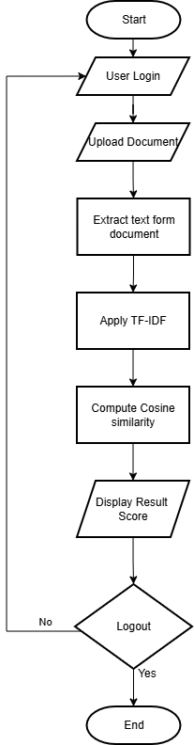
Figure 2. system Process flowchart
This flowchart shows the overall process form login to displaying similarity result.

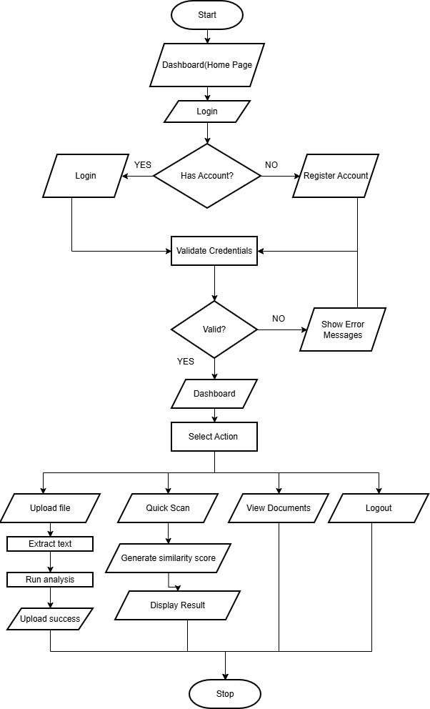
Figure 3. System flowchart diagram
The flowchart shows the system process from user login or registration to accessing the dashboard, where users can upload files, analyze documents, view records, or log out, ending the session.

  - Algorithms
The system uses algorithms to compare the similarity of documents. The algorithms used are TF-IDF and Cosine Similarity.
    - Text Extraction Algorithm
Text extraction is the process of extracting text from documents. In this system, when a user uploads a document, the system verifies the format of the document. Once it is verified, the system reads the contents of the file and extracts the text.
The text is then saved in the database for later use. The system is able to extract text from PDF, DOCX and TXT files using this algorithm. The text is significant as it is used for plagiarism detection.
3.6.2 TF-IDF Algorithm
TF-IDF means Term Frequency-Inverse Document Frequency. It is used to identify important words in a document.
Formula:
TF-IDF = TF × IDF
Where:
TF = how many times a word appears in a document
IDF = how important or rare the word is in all documents
Steps:
- Get the extracted text.
- Split the text into words.
- Count how many times each word appears.
- Give higher value to important words.
- Create a document vector.
Description:
TF-IDF is a way for the system to know if a word is important in a document. It decreases the value of common words and increases the value of important words.
3.6.3 Cosine Similarity Algorithm
The system uses cosine similarity to find the similarity of two documents. It calculates the similarity based on the angle between two vectors.
The formula for this is Cosine Similarity = (A · B) / (|A| × |B|), where A is the vector of the first document and B is the vector of the second document. The system retrieves the TF-IDF vector of the uploaded document and the TF-IDF vector of the documents in the database.
The system then compares the two vectors and calculates the similarity score. Once the computation is done, the user is presented with the result. The similarity measurement score is between 0 and 1, and the closer it is to 0, the less similar the documents are, and the closer to 1, the more similar the documents are.
3.7 Capstone Element
3.7.1 Software Requirements and Development
The system needs software tools to be developed and used properly.
Software Requirements:
Software | Purpose
HTML | Used for web page structure
CSS | Used for design and layout
JavaScript | Used for system functions
Node.js / Backend API | Used for server-side processing
Supabase / Database | Used for storing users, documents, and results
Web Browser | Used to access the system
Visual Studio Code | Used for coding

3.7.2 Implementation
Web-based system. It can be accessed via a web browser. Users can register, login, upload a file, and see the plagiarism results.
Users can upload documents for academic purposes. Once a document is uploaded, it is text extracted and saved. It matches the uploaded document with the documents in the database using TF-IDF and cosine similarity.
The web admin was also developed. The admin can see the list of users, documents, and similarity results. This allows the institution to store academic documents in a single system.
3.7.3 Testing and Validation
Testing was conducted to check if the system works correctly. Each main feature was tested one by one.
Test Case | Expected Result | Actual Result | Status
User Registration | User can create account | User created successfully | Passed
Login | User can log in | User logged in successfully | Passed
Upload Document | User can upload file | File uploaded successfully | Passed
Text Extraction | System extracts text | Text extracted successfully | Passed
Similarity Checking | System shows result | Result displayed correctly | Passed
Admin Dashboard | Admin can view records | Records displayed successfully | Passed
Logout | User can exit system | User logged out successfully | Passed

Validation Description
The system meets the requirements based on the testing result. It can upload file, get the text, calculate the similarity, and show the result. The administrator can also manage the system data.
The system was tested by confirming if it addresses the issues in the existing process. It centralizes the documents and speeds up the similarity check. This makes document management and plagiarism checking easier for users.

REFERENCES
Alzahrani, S. M., Salim, N., & Abraham, A. Understanding plagiarism linguistic patterns, textual features, and detection methods. IEEE Transactions on Systems, Man, and Cybernetics, Part C (Applications and Reviews), 42(2), 133–149. https://doi.org/10.1109/TSMCC.2011.2134847
Cao, L., & Ramesh, B. Agile requirements engineering practices: An empirical study. IEEE Software, 25(1), 60–67. https://doi.org/10.1109/MS.2008.1
Eisa, T. A. E., Salim, N., & Alzahrani, S. Existing plagiarism detection techniques: A systematic mapping of the scholarly literature. Online Information Review, 39(3), 383–400. https://doi.org/10.1108/OIR-12-2014-0315
Fielding, R. T., & Taylor, R. N. Principled design of the modern Web architecture. In Proceedings of the International Conference on Software Engineering (ICSE), 407–416. https://doi.org/10.1145/337180.337228
George, B., & Williams, L. A structured experiment of test-driven development. Information and Software Technology, 46(5), 337–342. https://doi.org/10.1016/j.infsof.2003.09.011
Jones, M., Bradley, J., & Sakimura, N. JSON Web Token (JWT) (RFC 7519). IETF. https://doi.org/10.17487/RFC7519
Kakkonen, T., & Mozgovoy, M. Hermetic and web plagiarism detection systems for student essays: An evaluation of the state-of-the-art. Journal of Educational Computing Research, 42(2), 135–159. https://doi.org/10.2190/EC.42.2.A
Lynch, C. A. Institutional repositories: Essential infrastructure for scholarship in the digital age. ARL Bimonthly Report, 226. https://www.arl.org/newsltr/226/ir/
Manning, C. D., Raghavan, P., & Schütze, H. Introduction to Information Retrieval. Cambridge University Press. https://doi.org/10.1017/CBO9780511809071
Nagappan, N., Maximilien, E. M., Bhat, T., & Williams, L. Realizing quality improvement through test-driven development: Results and experiences of four industrial teams. Empirical Software Engineering, 13(3), 289–302. https://doi.org/10.1007/s10664-008-9062-z
Potthast, M., Stein, B., Barrón-Cedeño, A., & Rosso, P. An evaluation framework for plagiarism detection. In Proceedings of the International Conference on Computational Linguistics (COLING), 997–1005.
Provos, N., & Mazières, D. A future-adaptable password scheme. In Proceedings of the USENIX Annual Technical Conference, 81–92. https://www.usenix.org/legacy/events/usenix99/provos/provos_html/
Rafique, Y., & Misic, V. B. The effects of test-driven development on external quality and productivity: A meta-analysis. IEEE Transactions on Software Engineering, 39(6), 835–856. https://doi.org/10.1109/TSE.2012.28
Salton, G., Wong, A., & Yang, C. S. A vector space model for automatic indexing. Communications of the ACM, 18(11), 613–620. https://doi.org/10.1145/361219.361220
Sandhu, R. S., Coyne, E. J., Feinstein, H. L., & Youman, C. E. Role-based access control models. Computer, 29(2), 38–47. https://doi.org/10.1109/2.485845
Schleimer, S., Wilkerson, D. S., & Aiken, A. Winnowing: Local algorithms for document fingerprinting. In Proceedings of the ACM SIGMOD International Conference on Management of Data, 76–85. https://doi.org/10.1145/872757.872770
Smith, M., Barton, M., Branschofsky, M., McClellan, G., Walker, J. H., Bass, M., Stuve, D., & Tansley, R. DSpace: An open source dynamic digital repository. D-Lib Magazine, 9(1). https://doi.org/10.1045/january2003-smith
Smith, M., Rodgers, R., Walker, J., & Tansley, R. DSpace: A year in the life of an open source digital repository system. In Research and Advanced Technology for Digital Libraries, 38–44. https://doi.org/10.1007/978-3-540-30230-8_4
Spärck Jones, K. A statistical interpretation of term specificity and its application in retrieval. Journal of Documentation, 28(1), 11–21. https://doi.org/10.1108/eb026526
Van de Sompel, H., Lagoze, C., Nelson, M., & Warner, S. The Open Archives Initiative Protocol for Metadata Harvesting (Version 2.0). Open Archives Initiative. https://www.openarchives.org/OAI/2.0/openarchivesprotocol.htm

